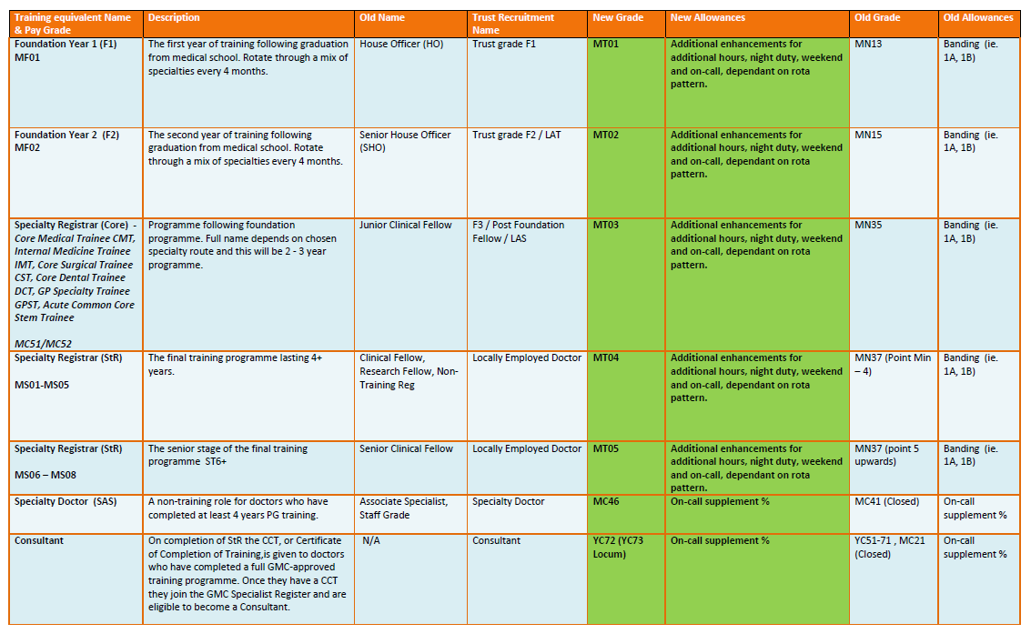

All medical staff recruited into the trust or having a contract extension must have the new grades applied. This is not a local decision but a nationally set requirement and is irrespective of foundation trust status.

Useful Links

https://www.bma.org.uk/pay-and-contracts/pay

https://www.nhsemployers.org/pay-pensions-and-reward/medical-staff

